**Project Design Phase – I**

**Proposed Solution**

|  |  |
| --- | --- |
| Date | 19 September 2022 |
| Team ID | PNT2022TMID14584 |
| Project Name | Customer Care Registry |
| Maximum Marks | 4 Marks |

Reference:

<https://app.mural.co/t/kumaraguru8114/m/kumaraguru8114/1667246740963/7df12b9a1a7600a4e328faaa886f118f89e4339f?sender=udd2bbcd686c2cd4fefc55238>

Step-1: Team Gathering, Collaboration and Select the Problem Statement

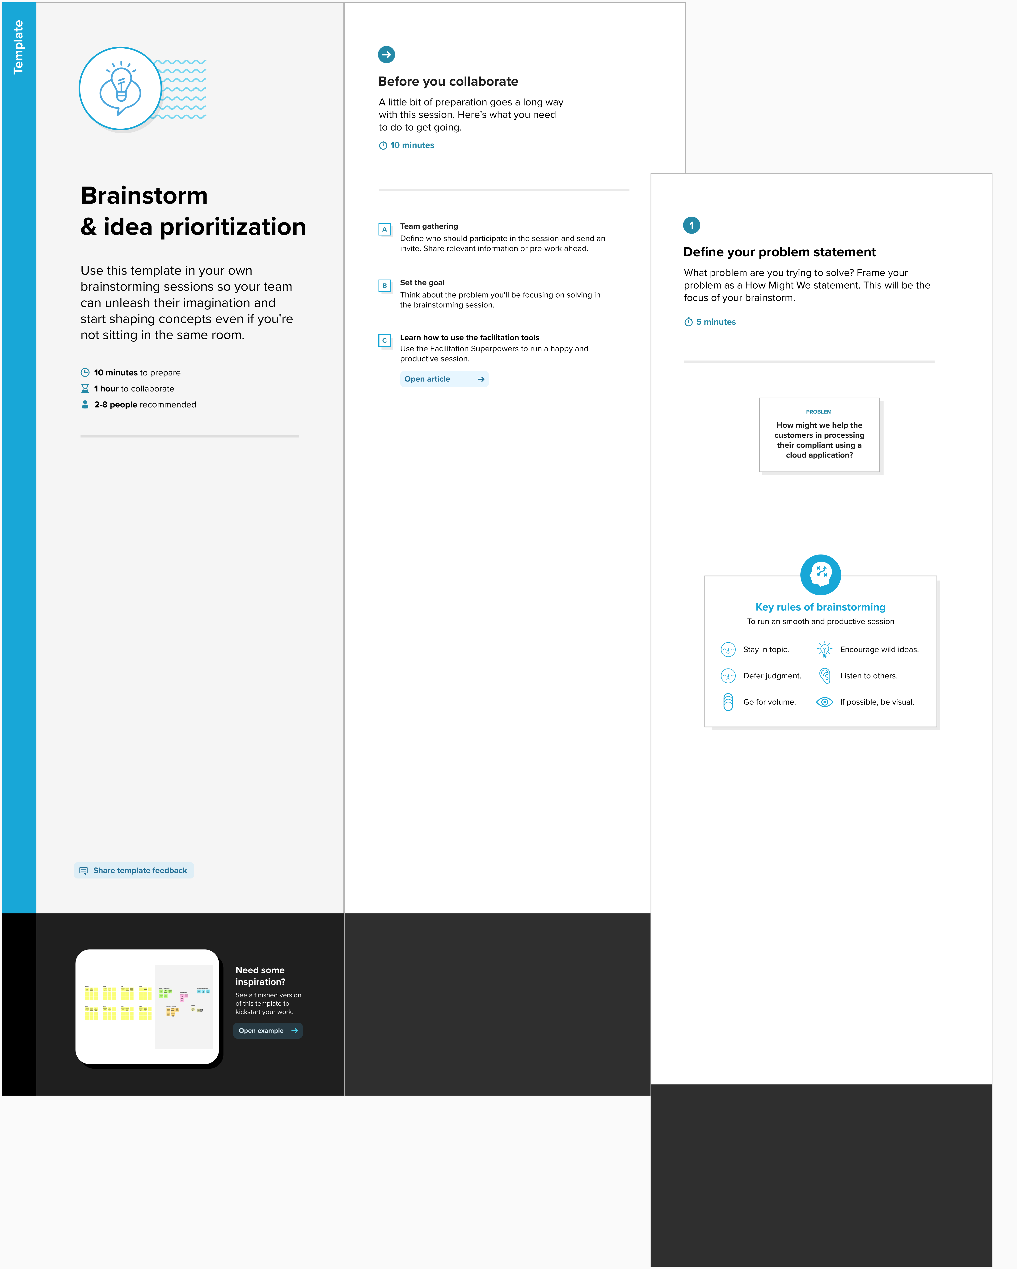

Step-2: Brainstorm, Idea Listing and Grouping

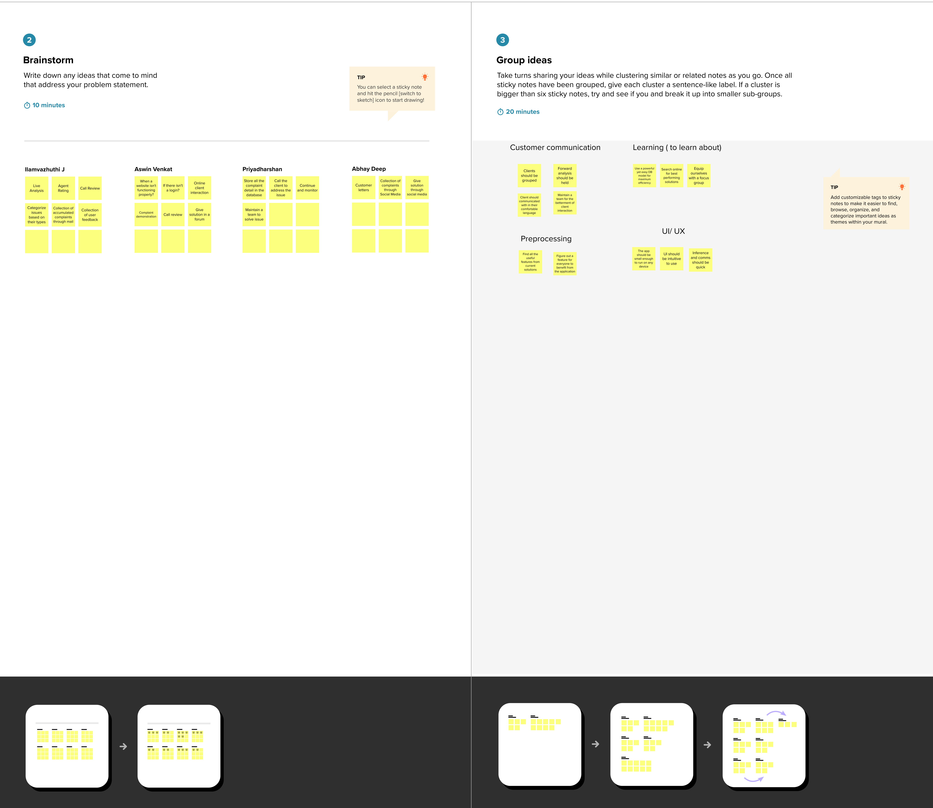

Step-3: Idea Prioritization:

